Weebly

- Go to weebly.com and sign up for free. Use your school email and password so it is easy to remember.
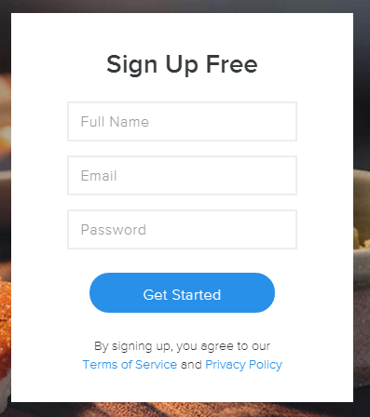
- Set up your site. Choose site. Then pick a theme for your web site.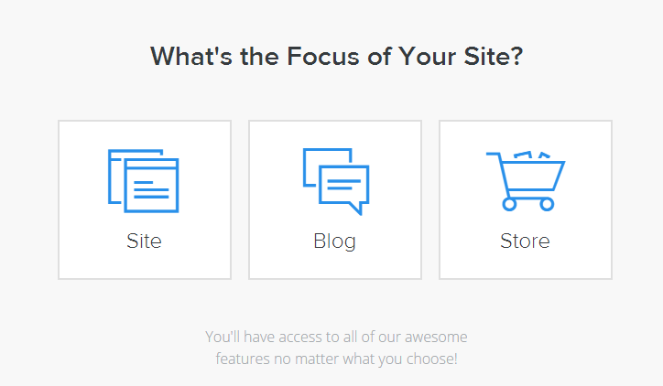
- Choose an address for your web page. The first choice is free so that is what we will choose. 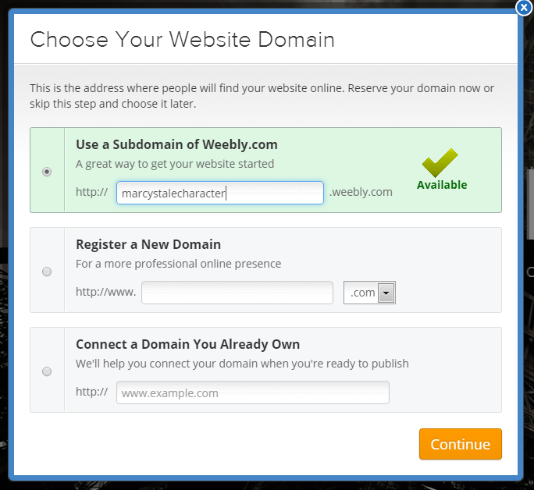
- Now we can build our web site.
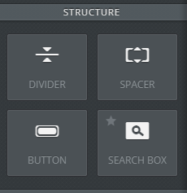
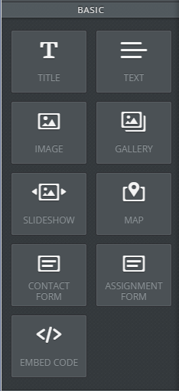
- You can drop and drag any of the buttons onto your web site to put in titles, texts, and pictures. Under media, you can add video, audio, flash, or a you tube video. You can also make buttons or add dividers.

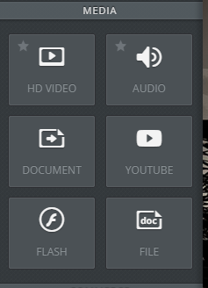

- Using the “photos” folder in your Weebly information, let’s try to put in
  - Title
  - Text
  - A photo
  - A photo gallery
  - A divider
  - A new page (+add page)
  - A slideshow
  - A button
  - Video (pay feature)
  - Audio
  - You tube video
https://www.youtube.com/watch?v=JnN-X9_ZErA

- When you are done, click “publish.”
  - Don’t accept the .com address because this is a pay feature.

